10.5: a)
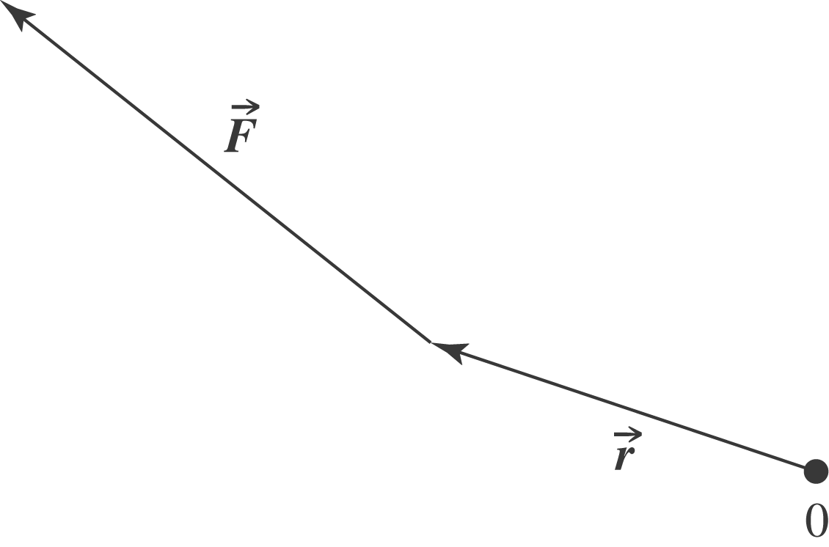
b) Into the plane of the page.
c)
